**Sample for PE**

**Subject: web design for everybody (WED201c)**

**Duration: 120 minutes**

**Description:**

Your final project is to create a web page that matches the example given here (wide viewport). All images using this project are putted in the folder “Images”.

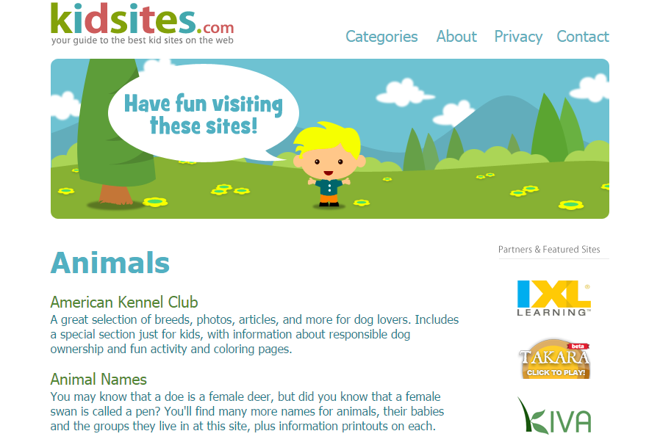

**Evaluation criterialess**

* A web page has to be divided some parts: header, article sections using semantic tags in HTML5 (header, footer, article, section, nav ,...) ***[3 points]***
* Your web page should is designed with good look on wide viewport **[2 points]**.
* All texts have to align matching the example given ***[2 point]***
* All background, font color of web page should use value hexadecimal ***[1 point]***
* Write java script code to reload this page when user clicks on the image **<<kidsites.com>>** ***[2 points]***